# STRINGERS

This was a very simple binary challenge were you had to find a flag in the binary file.

Running the binary on the command line using “./stringers” simply prints out a string. But running the strings command on the binary reveals the flag.

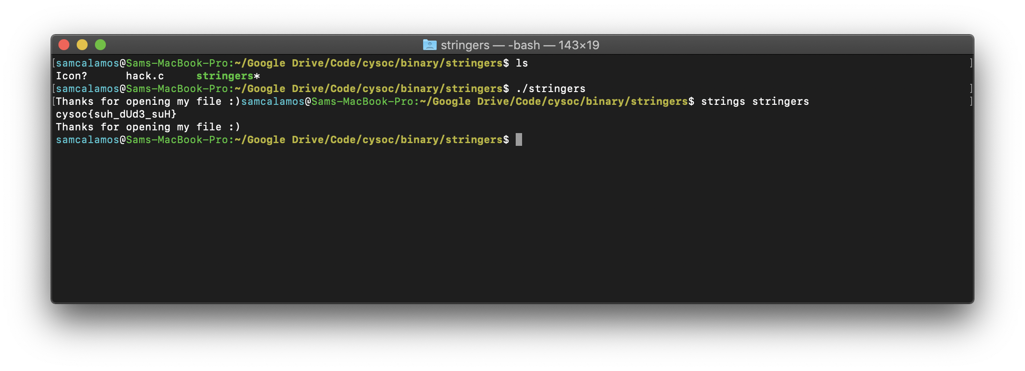

The source code of the compiled file was:

#include <stdio.h>

**void** main(**void**) {

**char** flag[64] = "cysoc{suh_dUd3_suH}";

printf("Thanks for opening my file :)");

}

Which gives the flag:

**cysoc{suh_dUd3_suH}**